Project title: Project CRM

Description:

This project will be a basic CRM software system for a business to business model.

The business using the CRM will market its product to potential customers and

support existing customers.

The products in question are IT products such as antiviruses, firewalls, backup software

Technologies needed:

* JDBC Driver for database connectivity
* If export is required, JFileChooser will be used

Login page:

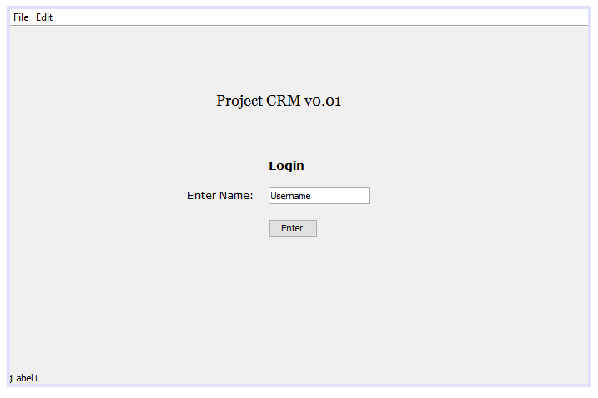

Customers tab:

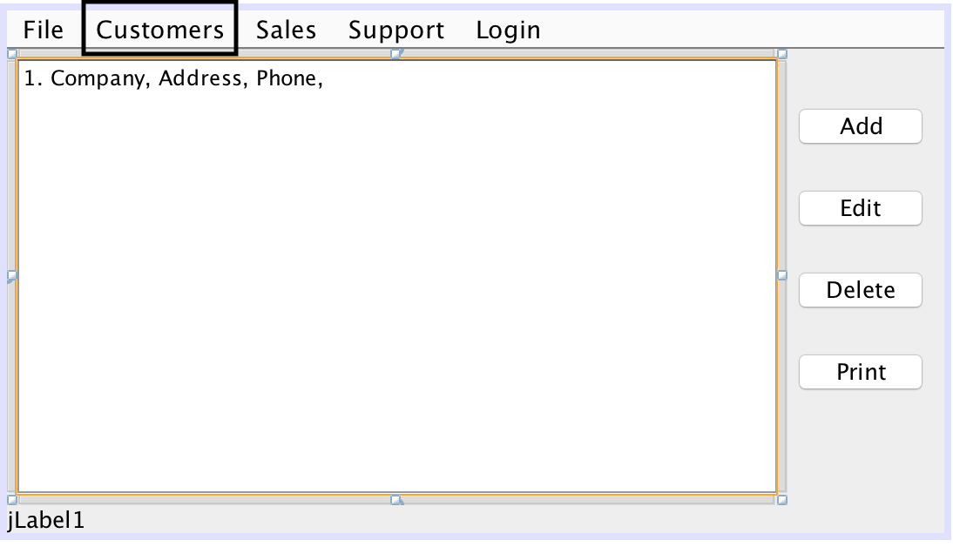

Sales tab:

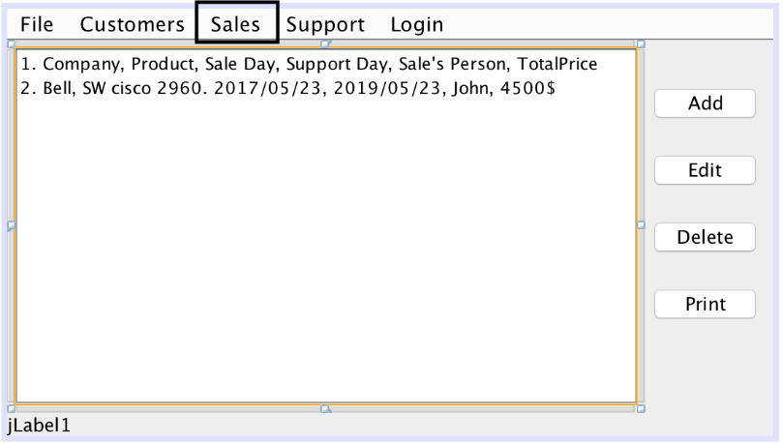

Support tab:

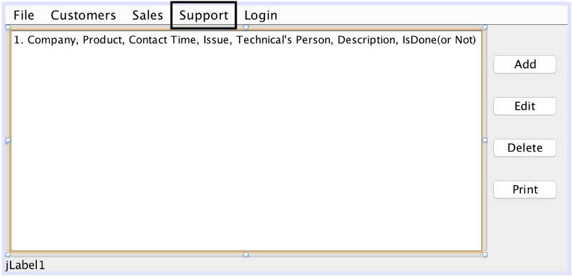

Add into sales:

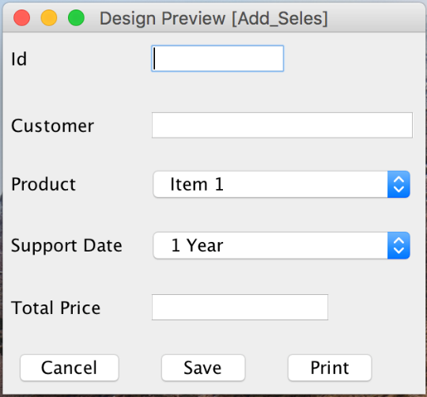

Add support ticket:

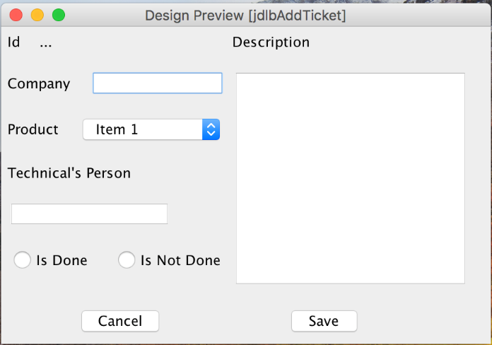

UML diagram:

